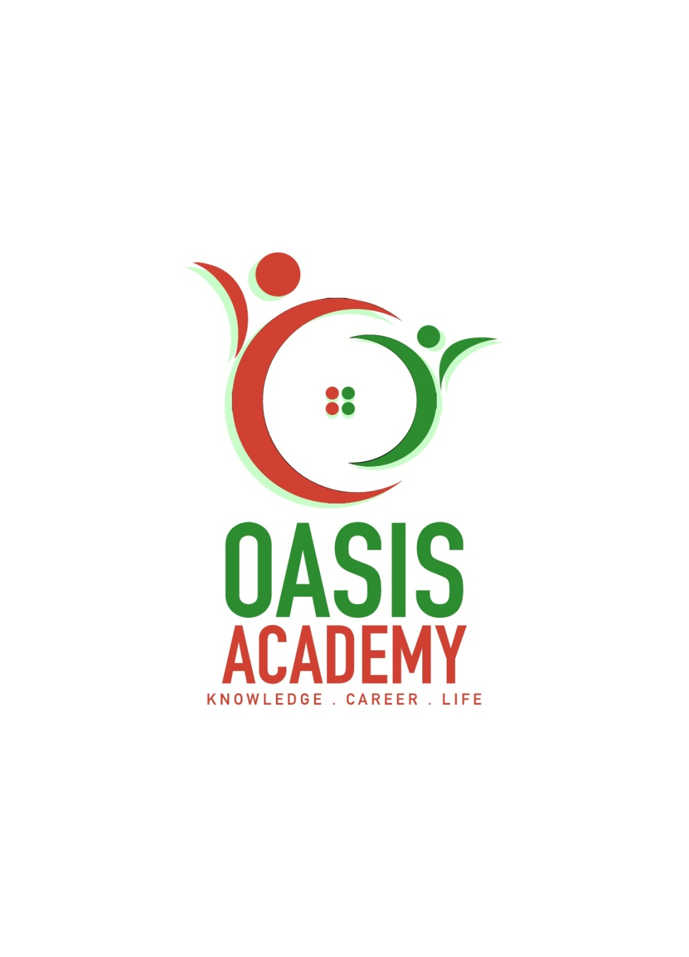

Name: **XXXXX**

Login ID: **XXXXXXXXXX**

Course title: **Essentials of XXXXXXXXX**

Subject Code: **XXXXX**

Submitted date:XXXXXXX

**Table of Contents**

|  |  |  |
| --- | --- | --- |
| No | Details | Page |
| 1 | Executive Summary | 2 |
| 2 | Introduction | 3 |
| 3 | Assignment Question |  |
|  | Part 1 | 4-5 |
|  | Part 2 | 6-8 |
|  | Part 3 | 9-12 |
|  | Part 4 | 13-14 |
| 4 | Conclusion | 15 |
| 5 | References | 16 |
| 6 | Appendix | 17 |

**Executive Summary**

In the module, I covered the topic about Human Resources Management within a Hospitality Management. In starting part, we can see the introduction of human resources. What is Human Resources Management and how importance our Human Resources Management in hotel industry? In first part, I studied the major activities and human resources operation in hospitality management and will explain the major steps in human resources. In the second part, I will describe in brief of human resources planning and planning trend in hospitality. Third part, I have understood the human resources functions and human resources policies and I will brief the function of management and how the policy applies accordingly in hospitality management. Finally, I will explain topic on the organizational behavior in hospitality management and more brief on groups and structure in organization.

**Introduction**

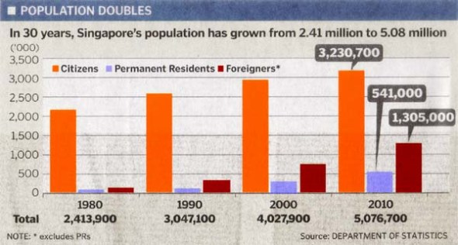Human resource management refers to the management of the personnel or personnel tasks involved in the management process. Human resource management includes job analysis, develop a human needs planning and recruitment training, training development, compensation and welfare management, performance evaluation, corporate culture, employee relations management. Apart from this, human resources management is getting more and more attention. In the mature system of economic development, human resources management must work together to strive for the best resource benefits, if the unsuitable staffing unsuitable positions, resource benefits will be all the loss. The modern economy stress balance and cooperation, improve management efficiency and quality, it is necessary to cooperate with the human resources to balance, with the most suitable people to do the most suitable work. The authorized strength of human resources platform, as a communication and collection information channels, the parties overall views, short to take long, to deal with remuneration, welfare and other matters. Human resources are the most important training and development, human resources development must be invested in training, to play the various sectors of human resources potential. Example, in Singapore, social sectors attach great importance to human resources, human resources is a very important area of work, human resources is a sustainable development of resources, is the impact of the overall situation, compared with the capital resources, has a more important role. The value of human resources comes from two aspects, that is physical and mental the combination of the two is the survival and development of enterprises is a necessary and sufficient conditions. It is also because manpower has two characteristics at the same time, making it more important than the capital resources. We also can see the graph, the population of Singapore has been steadily grown over the years.

(WORDPRESS,2013)

Figure 1:Singapore Population

**Assignment Questions**

**Question 1**

Define the Major Activities and Human Resources Operation in Hospitality Management.

The strategic objective of human resource management is to establish a human resources management mechanism that meets the development needs of the company, promotes the growth of employees, keeps innovating, transcends the self and ultimately enables employees and companies to develop together. The following are the major activities of human resource management.

**Recruiting**

Recruiting process is a combination of jobs and people who are looking for work. This is a process of joining, which brings job seekers and employers together, affecting the flow of people, the purpose of recruitment is to develop a number of potential qualified personnel. And for the recruitment process should attract qualified applicants, non-qualified personnel to provide adequate information on their own choice.

**Selecting**

Selecting is pick to choose. This is a selecting personal qualified positions to fill the job. The most basic purpose is to pick the most suitable candidates can successfully complete the work.

**Training**

Training is to change the skills, knowledge, attitudes or behavior of the staff, mainly to change the individual's current work and improve the specific skills and abilities of the hose to immediately perform the work. Training is a concrete job designed to make employees more effective in their current work. Furthermore, employees can develop better and faster, and have great help and contribution to future work.

**Evaluation**

Is the evaluation of the results of the work of the staff in a specific period, as a reference to personnel decisions such as salary adjustment, dismissal or promotion and other personnel decision-making reference or decision training needs and staff career development management. In addition, also can affect the staff fairness of the cognitive, so that the organization will reward and work performance link to achieve the purpose of motivating employees.

**Compensation and Benefits**

Develop effective pay and benefits systems to attract and retain talent and motivate employees to work hard. However, in determining salaries, benefits and other incentives, they must operate within the company's budget. And the compensation standards are all based on the policy description.

Hospitality Management major activities including two aspects, is the hotel manager in understanding the needs of the market under the premise of the hotel in order to effectively achieve the business objectives, follow certain principles, the use of various management methods. Examples, the hotel has the human, material, financial, time, information and other resources planning, organization, command coordination, control incentive and a series of activities the sum. And human resources is one of the six major resources of modern hotels, also too hotel's most basic, most important and very valuable resources. Human resource management is a difficult task, and a team of good quality staff is not naturally formed, but through the careful planning, organization, management and training of managers to generate, maintain and development. The aim of the human resources planning management is to create the hotel benefits by rationally allocating the cooperative relations of the labor organization and giving full play to and mobilizing the positive role of human resources and coordinating the various hotel services activities. Labor quota and the preparation of capacity management, is the hotel human resources planning and deployment management. The labor quota is an important basis for the formulation of staffing plans, mobilize employee zeal, the assessment of work performance and the distribution of labor remuneration. The compilers are based on the labor quota and determine all the hotel's manpower standards.

**Question 2**

Describe in brief on Human Resources Planning and Planning Trend in Hospitality.

Explain about what is your understanding on Action Plan Human Resource Planning in Hotel Industry.

Human resources planning is a business from the strategic planning and development goals, according to its internal and external changes in the environment, to predict the future development of human resources needs, as well as to meet the needs of human resources to provide the activities of the process. Human development including human forecasting, human supplement and personnel training, these three are indispensable in human resource planning. Human resource planning on the one hand to analyze the current situation of manpower to understand the dynamics of personnel. In addition, the future demand for human needs to do some predictions in order to increase and reduce the manpower of the overall consideration, and then based on the development of personnel training and training programs. The world of work has changed again and again. Human Resources Management as part of an organization, must be prepared to respond to the changing work environment. For human resource workers, it means understanding the diversity of globalization, the diversity of workforce, changing skill requirements, financial impact on the organization etc. In general, human resource management must take risks into new trends to keep relevant business development condition. The following are trends of planning in Human Resource Management.

**Outsourcing**

Outsourcing is human resource need for enterprises to be one or several of the human resources management functions or activity. Outsourced by other enterprises or organizations to manage to reduce labor costs to achieve maximum efficiency. Outsourcing can retain talent, these outsourcing companies to understand the needs of employees, employees can improve the comprehensive treatment, employee satisfaction, the loss rate naturally decline.

**Internship/Graduate Intake Programme**

Internships provide opportunities for college students who want to gain work experience in their respective fields and it is also possible to provide employers with cheap or free labor for simple labor if there is no cost on the job training. The main purpose of the intern job is not for the salary, some interns may stay in the company after the internship, because the company believes that they have been trained in practice, able to skillfully complete the work.

**Talent Pool**

Talent Pool is the enterprise talent pool of resources for enterprises to continue to enter the business development of all kinds of talents required. Each employee after the assessment of the ability to enter the talent pool management and sort by technical sequence level. And also regularly assess manage the personnel that have been recruited by the enterprise, adjust and arrange the positions of talents, promote the strength of the staff, ensure position, so as to play its greatest potential.

**Poaching and Raiding**

In the hotel's human resources trends, there are also unethical practices, is to recruit talent, and then provide some attractive benefits and other terms and conditions that are better than the current employer of the employee. This is a practice of buying talent, not development. This also become a challenge because human resource personnel need to face and combat piracy, which undermines the company's competitive advantage.

**E-Recruitment**

E-Recruitment is a special form of choice to avoid the crowd of large-scale concentration and close contact, to the employer to provide a broader choice of space, but also a lot of foreign job seekers have equal performance opportunities. There are many will be targeted to the work of social job seekers, graduates even if voted, but also because they do not meet the conditions and was returned by the employer.

|  |
| --- |
| **Action Plan Human Resource Planning in Hotel Industry** |
| **Step 01 (Assessing Human Resources)**   * According to business goals to determine the required staff conditions, through planning, recruitment, examination, evaluation, selection, access to business needs with the requirement of business strategy planning, the right people in the right place. |
| **Step 02 (Demand Forecasting)**   * Human resource demand forecasting is based on the enterprise‘s development plan and the internal and external conditions of the enterprise. Select the appropriate forecasting technology to forecast the quantity, quality and structure of human resource needs to conduct forecasting. |
| **Step 03 (Supply Forecasting)**   * Human resource supply forecasting is the core content of human resource planning and is a measure of the number and quality of the supply and external labor market that can be provided within a future period. And to meet the needs of the business to achieve the goal. |
| **Step 04 (Matching Demand And Supply)**   * Human resource planning refers to the scientific prediction, accurate analysis of their own human resources supply and demand situation, to develop a reasonable program to ensure that the needs of enterprises and organizations and employees to get long term interests. |
| **Step 05 (Action Plan)**   * In the human resource action plan is to use the maximum limit to ensure that the development of sustainable plans and to ensure that all the organizational objectives required to support the production capacity and then synchronize human resources activities with organizational goals while improving the organization's productivity. |

**Question 3**

Brief about Human Resources Functions and Human Resources Policies.

Describe the Functions of Management and How the policy applies accordingly in Hospitality Management.

**Six Main Functions of a Human Resources**

* **Recruitment**

Before the recruitment, do job analysis. In this process, we should carefully analyze the duties of a staff member and make a job description, and then determine the candidate's ability to apply for the job should be based on the degree of attractiveness of the candidates to choose the most appropriate recruitment methods, such as Newspaper advertising, employment agency etc.

* **Safety**

'Safety' in a workplace is very important. Regardless what industry what country and place, employers need to provide a safe working environment for the employees. While in the main function of human resources, there are logs that include workplace safety training and maintenance of federal authorized workplace damage and death reports.

* **Employee Relation**

Employee relations are a partnership, many are human resource disciplines that measure the relationship between employers and employees by measuring job satisfaction, employee engagement, and workplace conflict. Employee relations will have a strong impact on the development potential of the enterprise, which depends on the different social environment and the manager's basic view of the staff. Managers both regard employees as a fortune that can be formed by investing in resources.

* **Compensation and Benefits**

Compensation and benefits are within human resources management, and in different companies will be different compensation and benefits. In terms of compensation, human resources functions include setting the pay structure and assessing competitive pay practices.

* **Compliance (with law)**

Regulations and rules in different countries have different decrees, there are two important functions in the human resources have to comply with the Labor Discipline and Employment Act. Violations may lead to unfair employment practices or unsafe working conditions. Human resources personnel must be aware of federal and state employment laws, such as Chapter VII of the 'Civil Rights Act', the 'Fair Labor Standards Act', the 'National Labor Relations Law' and other rules and regulations.

* **Training and Development**

This process is related to the establishment of what kind of training system, which employees can participate in training and other issues. There are a wide range of training, ranging from on-the-job training to full-time learning and training courses offered by organizations outside the organization. When the organization has a plan for the development of core employees within the company, the relationship between training and development is obvious, and in this case people always try to make the company need to coordinate with the development of personal career.

**Four Main of Human Resources Policies**

* **Significance**

Every company has its own human resources policy manual. The human resources policy is designed to facilitate mutual understanding and communication between managers and other subordinates, and some companies will also outline the company's plan to employees. They provide staff to help promote their career development. If a company does not have human resource policy, it may lead to rules that do not specify compliance and a chaotic working environment. Employers should formulate a comprehensive policy from the outset, rather than a lot of problems.

* **Implementation**

Employers can develop their own procedures, and there are human resources consultants or employment lawyers to help review them. If it is necessary to reduce the human resources task, it can choose to outsource the human resources department to a third party provider. Because, each policy has its own laws and regulations, it must be in accordance with these standards. For example, although employers do not need to provide medical benefits, if they choose other food and beverage programs, the plan must comply with the guidance and principles of the IRS.

* **Communication and Maintenance**

Employers must correctly communicate their human resources policies to employees and comply with these policies when they recruit new employees. It is the responsibility that employers must take. So employers have to use different communication channels to reach employees, such as short information, E-mail, company bulletin boards, employee memos, organizing meetings or black and white documents.

* **Considerations**

Both employers and employees have the right to consult the government agencies that are enforced. For example, the Ministry of Social Affairs, the Ministry of Labor, the Ministry of Social Security and the Inland Revenue Department. These are implemented by the national labor department in accordance with national law.

|  |
| --- |
| **Functions of Management** |
| * **Planning** * The planning function of management can make the organization run very well and can control all the planned arrangements and determine the most effective results needed to accomplish that goal. The management and leadership at all levels of the organization must be coordinated with the planner. Which all help the company's knowledge of resources and business to achieve future goals. |
| * **Organizing** * The organizational function is a business in the daily operation of the indispensable structure. Organization like the whole company's leadership, control the overall structure, if not such a structure, work will become difficult and unsuccessful. Organizational work involves assigning tasks and responsibilities to employees, and specific skills are effective in helping companies achieve their goals. |
| * **Coordinating** * The coordinating function involving management's communication, supervision and guidance is a very important leader. Because it controls all the organization, planning, and staffing projects of the company and ensures that all activities have a common role in the interests of the organization. Coordination is usually carried out in corporate planning meetings, as it is important to ensure that all departments are in a common direction. |
| * **Controlling** * The controlling function of management is very useful for all organizations to run. The performance of each employee's performance standards are through the supervision of staff control, to meet these standards and levels. During the control process, you will usually encounter some special circumstances and problems, so you need to create new performance standards to solve. The level of performance of the organization will affect the success of all aspects. |

In modern hotel management, any management activities before the start, the first need to develop a plan, for example, after determining the objectives and programs of the hotel', it is necessary to analyze in detail the specific actions that have made specific requirement for the work of the various departments within the hotel. The plan developed by the hotel should be implemented smoothly, and each unit and member of organization needs to from a reasonable cooperative relationship in the implementation of the work, for example, with the staff, the appropriate staff placed in the hotel appropriate positions, so that each work are the proper person to do it. Managers use the power they have to direct, influence, and motivate members of the organization to work hard to achieve organizational goals, and managers use appropriate methods to maintain the enthusiasm of the organization's members so that they can fully develop their capabilities. Control is to ensure that the hotel departments, each ring can be scheduled to operate to achieve the objectives of the hotel organization of a management activities. Mainly according to the planning standards check the various links to determine the results of their work to ensure that the hotel organization goals and plan achieve effective.

**Question 4**

Explain in detail about Organizational Behavior in Hospitality and brief on Groups and Structure in Organization.

Pugh(1971) have pointed out Organizational Behavior is concerned with "the study of the structure, functioning and performance of organizations and the behavior of groups and individuals within them". Organizational Behavior is an application system that studies the impact on organizational behavior in individuals and groups and structures. The resulting knowledge will then be applied to improve the effectiveness of the organization. Organizational Behavior be a management, it is based on behavior, with psychology, sociology, influence of economics, political sciences, medical science, socials psychology and other related disciplines. About organizational behavior have many definitions, have the influence of individuals, groups, and structures on the behavior of the organization in order to apply this knowledge to improve the effectiveness of the organization. The individual in the organization included the basis is the ability to control emotions, work attitude and job satisfactions are personality and personal values, instinctive perception and individual decision making and also basic motivation. The group in the organization understand the work team, communication, know the basic point of view of leadership and contemporary leadership issues and understanding power and politics details. The organization structure of the basic organizational culture of human resources policy and reality. Organizational behavior is the overall behavior, not the personal alone behavior of the members of the organization, the motive is based on the purpose of the organization established with a clear purpose. Organizational behavior is the behavior of all members of the joint activities, but also through the individual members of the organization To achieve, but also affect the individual behavior of members. We need to understand about the concepts in the organization, there are other functional areas that have the ability to predict and influence how other behaviors are applied and marketing. Which we can better understand the self and other people's expectations of understanding. But also help you better handle people to understand that human behavior will help and improve your interpersonal skills. Organization behavior provides a importance roadmap for life, the use scientific research to help and understand and predict the organization of life and activities, also help us in a different way understand themselves and others. In addition, also help companies understand the motivation foundation and industry have a good relationship, learning organization behavior can manage the career so that the economy has growing rapidly.

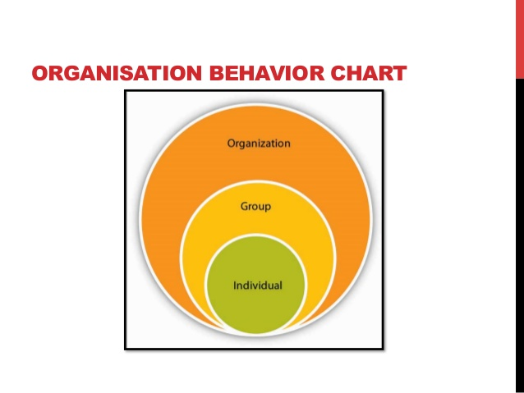 (PAYAL DEEP,2012)

Figure 2:Organizational Behavior Chart

**Models of OB**

|  |  |  |  |  |
| --- | --- | --- | --- | --- |
| Basic of model | Autocratic | Custodial | Supportive | Collegial |
| Managerial  Orientation | Power | Economic  Resources | Leadership | Partnership |
| Employee  Orientation | Authority | Money | Support | Teamwork |
| Employee  Psychologic  al Result | Dependence  On boss | Dependence on org | Participation | Self  discipline |
| Employees  Need met | Subsistence | Security | Status& recognition | Self actualization |
| Performance  result | Minimum | Passive cooperation | Awakened drives | Moderate  enthusiasm |

Figure 3:Organizational Behavior Models of OB

**SOBC MODEL**

SOBC Model is a very practical, is based on human behavior to analyze, cause and follow the causal relationship is the behavior of people.

|  |
| --- |
| **Stimulus => Organism => Behavior => Consequences**  (Cause) (individual) (action) (result) |

Figure 4:Organizational Behavior SOBC Model

**Conclusion**

In this assignment, I learned a lot about human resource management knowledge and the overall operation of its importance. In the first question, the major activities of the human resources are described, such as recruitment, training, development, motivation etc. We can see in these activities, to promote staff development, beyond the self. Simultaneously help employees improve quality, create company efficiency and effectively achieve business goals. In the second question, we can understand the human resources planning and planning trends. Such as assessment, demand and supply forecasting throughout the action plan to develop and assess future human needs. In this conclusion of second question, the plan is very important to an enterprise, to maintain the relevant business development, to ensure and improve production capacity, to complete the organizational goals. In the third question, described about the human resources functions and policies. That is to say, recruitment, safety, employee relation, compensation and benefits and compliance by law. Human resources all the functions and policies are indispensable, which helped the development of enterprises to help employers and employees of mutual understanding and communication. Each policy has its own legal rules, and it is important to develop a management plan that can effectively achieve organizational goals. Coupled with the last question, I understand the key elements of organizational behavior and understand the importance of human organization and behavior in modern society. There are three kinds of organizational behavior, there are individuals, groups, structures, This knowledge is to improve the effectiveness of the organization. Above all in the last question, organizational behavior allows us to better understand ourselves and others, improve interpersonal relationships, help understand life, manage the cause of the cause to a higher level. Human resources is now one of the six major resources in the community, the economy plays an important role, is the most important and most valuable management.

**References**

1. WORDPRESS, **(2013)** *SINGAPORE POPULATION*.

RETRIVED FROM:[https://eakky.wordpress.com/tag/white-paper-on-singapore-population-2013/](mailto:https://eakky.wordpress.com/tag/white-paper-on-singapore-population-2013/)

1. PAYAL DEEP**,(2012)** *ORGANIZATIONAL BEHAVIOR.*

RETRIVED FROM:[https://www.slideshare.net/payalrchhabra/organisational-behavior-15668552](mailto:https://www.slideshare.net/payalrchhabra/organisational-behavior-15668552)

1. ZEINUL HALEEM,**(2014)** *HUMAN RESOURCE MANAGEMENT IN HOTEL INDUSTRY*.

RETRIVED FROM:[https://www.slideshare.net/ZeinulHaleem2/human-resource-management-in-hotel-industry](mailto:https://www.slideshare.net/ZeinulHaleem2/human-resource-management-in-hotel-industry)

1. DR.RAJASSHRIE PILLAI,**(2014)** *CHAPTER 1 ORGANIZATIONAL BEHAVIOR*.

RETRIVED FROM:[https://www.slideshare.net/rajasshrie1/chapter-1-ob-38248150](mailto:https://www.slideshare.net/rajasshrie1/chapter-1-ob-38248150)

1. MANISHRAY,**(2009*)*** *BASIC CONCEPTS OF ORGANIZATIONAL BEHAVIOR*.

RETRIVED FROM:<mailto:https://www.slideshare.net/manishray/1basicconceptsofob>

1. WIKIPEDIA THE FREE ENCYCLOPEDIA,**(2017)** *HUMAN RESOURCE MANAGEMENT*.

RETRIVED FROM :[https://en.wikipedia.org/wiki/Human_resource_management](mailto:https://en.wikipedia.org/wiki/Human_resource_management)

1. CALIA ROBERTS,**(2017)** *FIVE FUNCTIONS OF MANAGEMENT.*

RETRIVED FROM:[http://smallbusiness.chron.com/five-functions-management-leading-56418.html](mailto:http://smallbusiness.chron.com/five-functions-management-leading-56418.html)

1. RICK SUTTLE,**(2017)** *MAJOR CATEGORIES OF HR MANAGEMENT ACTIVITIE.*  
   RETRIVED FROM:[http://smallbusiness.chron.com/seven-major-categories-hr-management-activities-37354.html](mailto:http://smallbusiness.chron.com/seven-major-categories-hr-management-activities-37354.html)
2. LSE,**(2016)** *INTRODUCTION TO HR.*

RETRIVEDFROM:[http://www.lse.ac.uk/intranet/CareersAndVacancies/careersService/EmploymentSectors/BusinessManagementHR/HR/Home.aspx](mailto:http://www.lse.ac.uk/intranet/CareersAndVacancies/careersService/EmploymentSectors/BusinessManagementHR/HR/Home.aspx)

1. SURBHI S,**(2015)** *DIFFERENCE BETWEEN PERSONNEL MANAGEMENT AND HUMAN RESOURCE MANAGEMENT.*RETRIVED FROM:[http://keydifferences.com/difference-between-personnel-management-and-human-resource-management.html](mailto:http://keydifferences.com/difference-between-personnel-management-and-human-resource-management.html)
2. PINTEREST,*HUMAN RESOURCE MANAGEMENT*.

RETRIVED FROM: [https://www.pinterest.com/bankofi/human-resource-management/](mailto:https://www.pinterest.com/bankofi/human-resource-management/)

**Appendix**

Example:

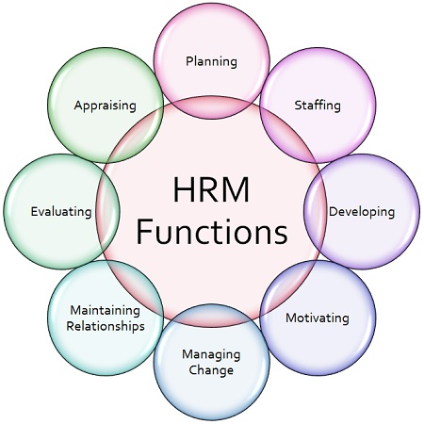

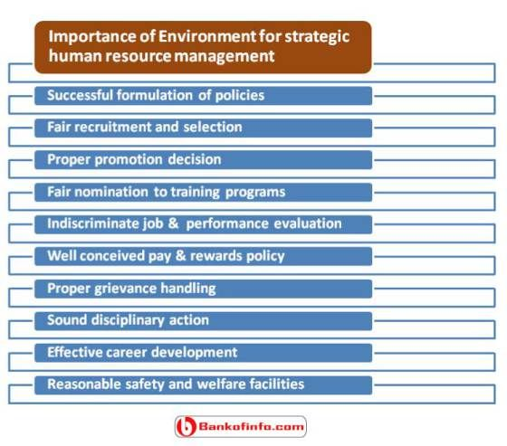

**The End**